Low Level Design (add Hotel module)

Project Code | Team1
Project Name | Hotel Booking Management System

Prepared/Modified by | Role | Date of Preparation
Vivek Karna | Senior Analyst | 13/10/2017
Reviewed by | Role | Date of Review
Dishang Jain | Senior Analyst | 16/10/2017
Approved by | Role | Date of Approval
Anjulata Tembhare | Mentor
Circulation List | vivek.karna@capgemini.com  dishang.jain@capgemini.com  mayur.mishra@capgemini.com  ashlesha.sortey@capgemini.com  shivam.rastogi@capgemini.com  mahendra.bisht@capgemini.com  utkarsh.mohan@capgemini.com | Version Number of the template:1.0
Version Number | 1.3

Table of Contents

1. Description Of The Unit 3
2. References 4
3. Dependencies / Assumptions 5
4. Class Diagrams 6
5. Sequence Diagrams 7
6. Design Components 8
6.1 List Of UI Components 8
6.2 List Of Design Classes 8
7. Re-Usable Routines/Components 9
8. Messages 10
9. Configuration Files 11
10. Crud Matrix Table 12
11. Data Mapping Matrix 13
12. Action Flow Matrix 14
13. Stored Procedures 15
REVISION HISTORY OF THE WORK PRODUCT 17

Description Of The Unit

The add Hotel module allows the admin of the application to add new Hotel into the database. This module can be used only by the admin of the application.

On clicking on the add button in the admin home page, the admin is redirected to a add hotel page. The admin enters all the details of the hotel like hotel name, address, description, city, average rate of one night, primary phone number, secondary phone number, rating, Email Id and Fax. If the entered room details are invalid, appropriate error messages are displayed.

After entering all the hotel details, the details are inserted into the database on clicking the add button.

References

Reference | Description
Repository reference | https://IGTEBLRSVNTNG.igatecorp.com/svn/oct3_Team1
Class Diagram | /Project Documents/Design Documents/HLD/Class Diagrams
URS | /Project Documents/Requirements/Case Study/Ecommerce-grp1 and grp3.doc
UTP | /Project Documents/Test Plan/UTP/Test Cases/AddProduct /UTP_AddProductModule.xlsm
DB Design | /Project Documents/Design Documents/HLD/DB Design/E-Commerce_GROUP_DBDESIGN.xls

Dependencies / Assumptions

Dependencies:
The admin should be logged in.

Assumptions:
The admin login details are stored in the database.

Class Diagrams

Class Diagram

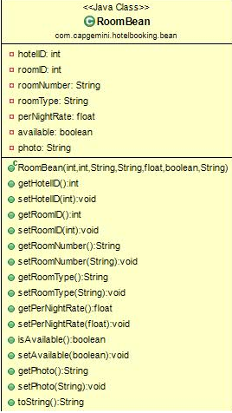

Sequence Diagrams

Sequence Diagram
NA

Design Components

List Of UI Components
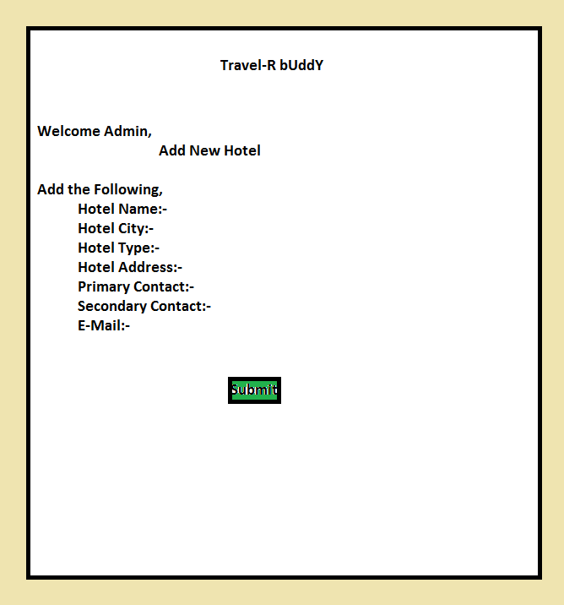

List Of Design Classes
Sr. No. | LLD Name | Class Name | Method Name | Method Description
1 | Add Hotel Module | HotelBean | Appropriate getters and setters methods | Getters retrieve the property values and setters set the property values
2 | Add Hotel Module | Hotel Booking Controller | ModelAndView addNewRoom()  ModelAndView addHotelDetails(@ModelAttribute("hotelBean") HotelBean hotelBean  adminService.addHotelDetails(hotelBean); | Admin can add new hotel. The control passes to AddNewHotel.jsp.  It retrieves the model Attribute-hotelBean with all the values of hoteldetails in it.  It passes the the object of hotelBean to service.
3 | Add Hotel Module | AdminService | addHotelDetails(HotelBean hotelBean)  dao.addHotelDetails(hotelBean) | Retrieves the values of Hotel Details from object hotelBean from the Controller.  Calls AdminDao class for insertion of hotelDetails in the database.
4 | Add Hotel  Module | AdminDao | addHotelDetails(HotelBean hotelBean)  entityManager.persist(hotelBean); | Retrieves the object hotelBean from the AdminService and stores in the database.  Inserts the hotel details into the database using persist method.

Re-Usable Routines/Components

Re-Usable Routines/Components

- CSS files
- Javascript files
- DataAccessException class
- Database properties files
- Logger properties files

Messages

#. | Type | Message Text
M1 | Error | Enter a valid product name
M2 | Error | Enter a valid product description
M3 | Error | Select a product sub-category
M4 | Error | Enter a valid product price
M5 | Error | Enter a valid product quantity
M6 | Error | This field cannot be empty

Configuration Files

File Name | Path | Description
oracle.properties | /HotelBookingManagementSystem/src | To configure database connection.
Web.xml | /HotelBookingManagementSystem/src | To configure the bean properties.
HotelManagement.xml | /HotelBookingManagementSystem/src | To configure the request mapping and view resolver.
Eshop_logger.properties | /Development/Source | To configure the logger.
Eshop_error.properties | /Development/Source | To configure error messages.

Crud Matrix Table

# | Table Name | Create | Read | Update | Delete
1. | Hotel_Details | Y | Y | Y | Y
3. | Hotel_Id_Sequence | N | Y | N | N

Data Mapping Matrix

Sr. No. | Screen Label | Field Source | Field Type | Data Type | Max Length | Data Flow | Mandatory
1 | Hotel Name | NA | Label | NA | NA | UI | NA
2 | hotelName | hotelDetails.hotelName | TextBox | Varchar2 | 30 | UI→D | Yes
3 | Address | NA | Label | NA | NA | UI | NA
4 | txt address | hotelDetails.address | TextBox | Varchar2 | 50 | UI→D | Yes
5 | City | NA | Label | NA | NA | UI | NA
6 | txt city | hotelDetails.city | TextBox | Varchar2 | 10 | UI→D | Yes
7 | Phone Number 1 | NA | Label | NA | NA | UI | NA
8 | txt phoneNumber1 | hotelDetails.phoneNo1 | TextBox | Varchar2 | 10 | UI→D | Yes
9 | Phone Number 2 | NA | Label | NA | NA | UI | NA
10 | txt phoneNumber2 | hotelDetails.phoneNo2 | TextBox | Varchar2 | 10 | UI→D | Yes
11 | Rating | NA | Label | NA | NA | UI | NA
12 | txt rating | hotelDetails.rating | TextBox | Varchar2 | (6,2) | UI→D | Yes
13 | E-Mail | NA | Label | NA | NA | UI | NA
14 | txt email | hotelDetails.email | TextBox | Varchar2 | 30 | UI→D | Yes
15 | Fax | NA | Label | NA | NA | UI | NA
16 | txt fax | hotelDetails.fax | TextBox | Varchar2 | 6 | UI→D | Yes
13 | Submit | NA | Button | NA | NA | UI | NA

Legend
D → UI (Database to User Interface)
UI → D (User Interface to Database)
UI (User Interface Only)

Action Flow Matrix

Sr. No. | Action | Description | Process
1 | On click of Login Button in LoginPage | Redirected to the Admin.jsp  where all the functionalities of admin are present. | The admin clicks on the add New Hotel in the admin homepage and gets redirected to the add page.
2 | On click of Add New Hotel button in add page | The room details are inserted into the database. | Data is entered in the fields by the admin which gets inserted into the database when add button is pressed.
3 | On click of Homepage button in Add page | Redirected to admin homepage which consists of all functionalities admin can perform | The admin on clicking on the Homepage button in add page gets redirected to the home page.

Stored Procedures

# | Stored Procedure Name  (with Description) | Input/Out Parameters | Type | Size
1. | NA | NA | NA | NA
REVISION HISTORY OF THE WORK PRODUCT

# | Date | Version # | Section Changed | Details of changes made | Approved By
1 | 14/10/2017 | 1.0 | LLD prepared | N/A | Anjulata Tembhare
2 | 16/10/2017 | 1.1 | Reusable components | Reusable components added. | Anjulata Tembhare
3 | 16/10/2017 | 1.2 | Reusable components,  References,  Data Mapping Matrix. | Reusable Components added.  File name with relative path is added in the references section.  The name of text boxes(screen label is changed). | Anjulata Tembhare
4 | 17/10/2017 | 1.3 | Configuration files,UI Components | Paths of the configuration files is updated and UI components (Screen Shots) added. | Anjulata Tembhare

